**Photobookmart FTP Sync**

**User Guide**

1. Install the application

* Copy all files of the Photobookmart FTP Sync to one location on your hard drive.

Then on your computer it will look similar to the screenshot below

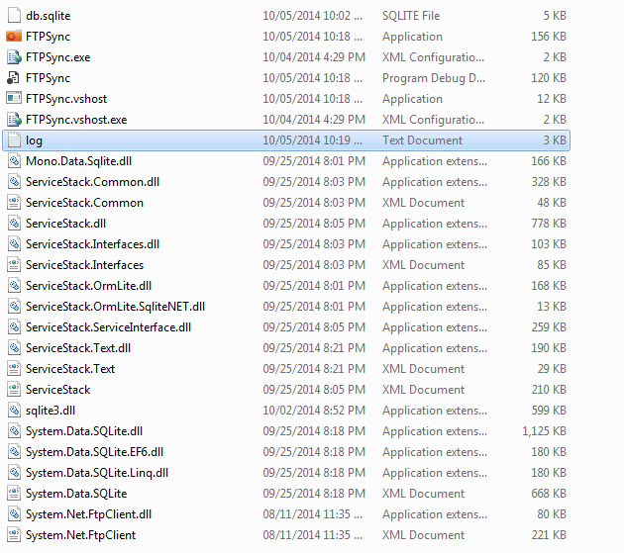

Now please focus on the file FTPSync.exe and log.txt.

When you don’t know that the FTPSync is working or not, you can open the log.txt to see the file content. While running, the FTPSync.exe will update the log file always.

* Execute FTPSync.exe.

Then you will see the screen as below:

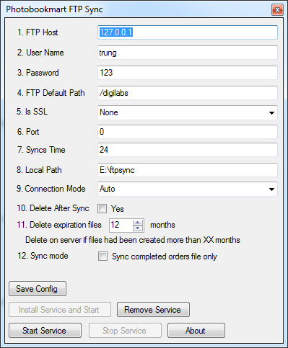

* Do configure for the app.

Syncs Time: How many times system will do the sync, per day

Delete after Sync: After sync successfully, system will delete files on server or not. We suggest that you don’t enable this option. Leave the files on server to cut your risk in case your local server does not work.

Delete expiration files : automatic delete all directory and files on server uploaded in the past XX months.

Sync mode: if you checked sync completed orders file only, then only directory with name in format XXXXXX (6 digits) will be sync. The other will be ignoring.

Local path: directory path on your local that we will store all sync files into

* Click on Save to save the configuration
* Click on button Install Service and Start to let Windows start our app after boot.
* When you want to stop the sync process, click on Stop Service. When you want to continue the process again, click Start Service.

**Notice:** this application uses a method called HASH to calculate the checksum of the files on your server. When the content of files on your server change, checksum will be changed. Please ask your IT Admin to configure the FTP Server to enable HASH. Without HASH, the FTPSync only compare the file content.